UNIVERSITY OF MISSOURI KANSAS CITY

10/18/2013

Venkata Vamsi Siva Krishna Vura

Sandeep Keshetti

Venkatesh Kadiyala

e-Education

Second Increment report

**Introduction**

Computer-Based Trainings (CBTs) will be a good solution to printed learning materials since rich media, including images, videos, messages or animations, can easily be used to enhance the learning. Another advantage of computer based training is that they can be easily distributed to a large number of people at a relatively low cost once the initial development is completed. Typically the creation of good CBTs requires large number of resources.

**Functional Requirements**

**Working with Remote Instruments**

Through a browser interface, makes it possible for students around the world can use this application. This application build in web based 3-tier architecture. The data of the user can be stored in remote database.

**User**

Here user is end user of the application. He can use this application remotely that means from anywhere he can use this application. He can login into his own space after registration. He can learn the content with the help of audio. After he can check his performance by online tests.

**Non-functional Requirements**

The Online Learning system shall be multi-tier, web based solution (have web based front-end for users and for system administrative functions), with the centralized database.

The application will be architected and designed using the principles of Service Oriented Architecture (SOA) The System will be compatible with all leading web browsers especially with Microsoft Internet explorer and/or Mozilla Firefox etc.,

The learning system that is going to create is very simple it has so many drop box menus, scrolling tabs and selection buttons more than that it is also more useful to illiterate because they can easily use such type of tools.

**Technologically and Architectural requirements**

**Hardware Requirements**

* System : Intel core 2 Duo
* Hard Disk : 40 GB.
* Ram : 512 Mb.

**Software Requirements:**

* Operating system : Windows XP.
* Coding Language : JAVA
* Data Base : MySQL
* Server : Tomcat 6.0

Class Diagram for Login Page

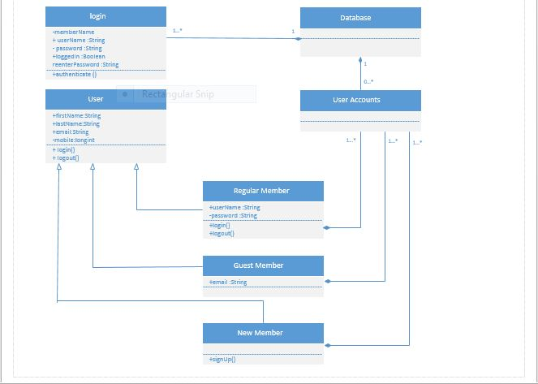

Sequence Diagram for Login Page

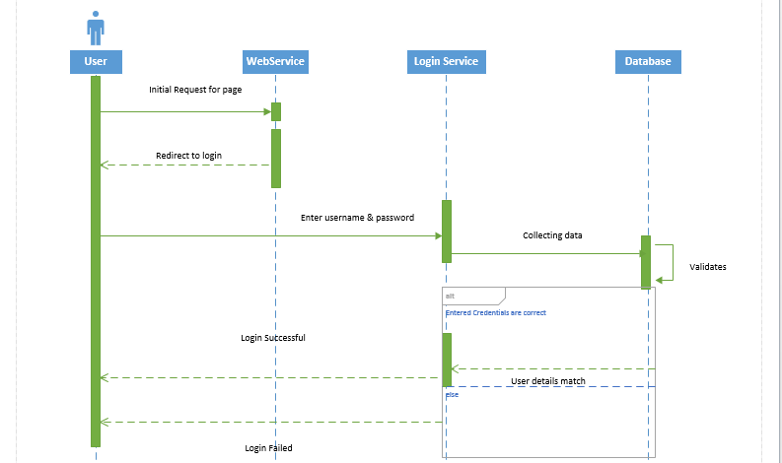

Class Diagram for e-Education

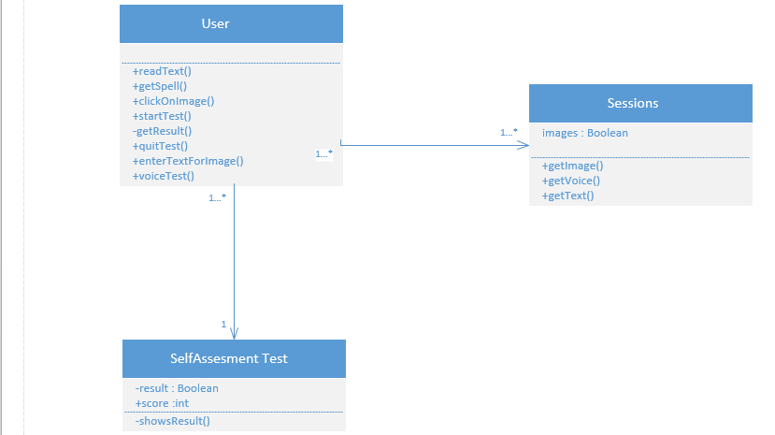

Sequence Diagram for e-Education

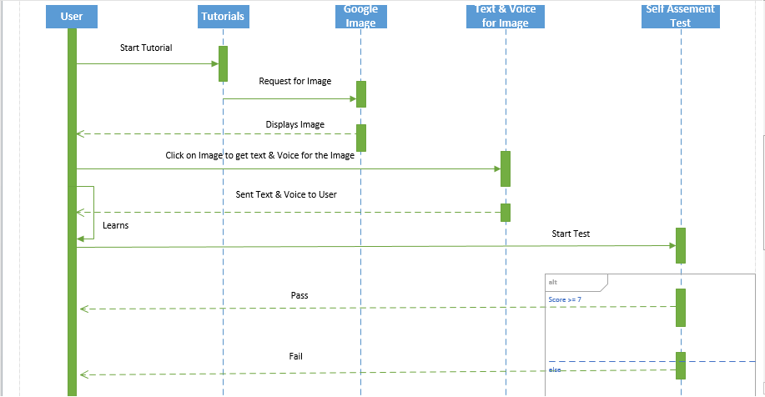

**SERVICE DESCRIPTION:**

Computer based tests presents an innovative idea in the field of learning and provides a great way to gaining the knowledge. By using the online services by the wide range of electronic learning solutions such as Web-based courseware, online alphabets learning, and online words speaking using audio and visually. Illiteracy people easily learn the how to read and writes. It is helps to decrease the illiteracy.

The manual system is costly and time consuming. Information is not available in methodical manner. Sometimes system doesn’t provide the updated information. It generates more hassle for the learner. Searching for the desired content is quite complex. Information is in distorted manner. Higher degree distortion creates confusion in mind.

**Implementation**

We installed MySQL database server and tomcat 6.0. The source code is written in java language.

We use **SQL yog, a GUI tool for MySQL.**

**Features of SQL yog :( source: Wikipedia)**

* Tabbed interface for connections. Connections can be given a color for identification.
* Editor with syntax highlighting and various automatic formatting options.
* Intelligent Code Completion.
* Data manipulations (INSERT, UPDATE, and DELETE) may be done from a spreadsheet-like interface. Both raw table data and a result set from a query can be manipulated.
* Rich context menus etc. for performing common tasks without writing SQL.
* Visual Schema Designer.
* Visual Query Builder.
* Query Formatter.
* Connectivity options: Direct client/server using MySQL API (SSL supported), HTTP/HTTPs Tunneling, SSH Tunneling.
* Backup Tool for performing unattended backups. Backups may be compressed and optionally stored as a file-per-table as well as identified with a timestamp.
* 'SQL Scheduler and Reporting Tool' - a tool for scheduling and automating execution of any sequence of SQL statements. Result of queries may be sent as HTML-formatted reports.
* Schema/Structure Synchronization and Data Synchronization.
* Query Profiler and Redundant Index Finder.
* All automated jobs have mail alerting and reporting options.
* Optionally portable. All files used by SQLyog may be saved to a removable drive etc.
* A 'Data Searchfeature using a Google-type search syntax translated transparently for user to SQL.
* Form viewto display one row at a time - a great way to enter/edit data.

Showing the tasks doing by individual members in phase-2:

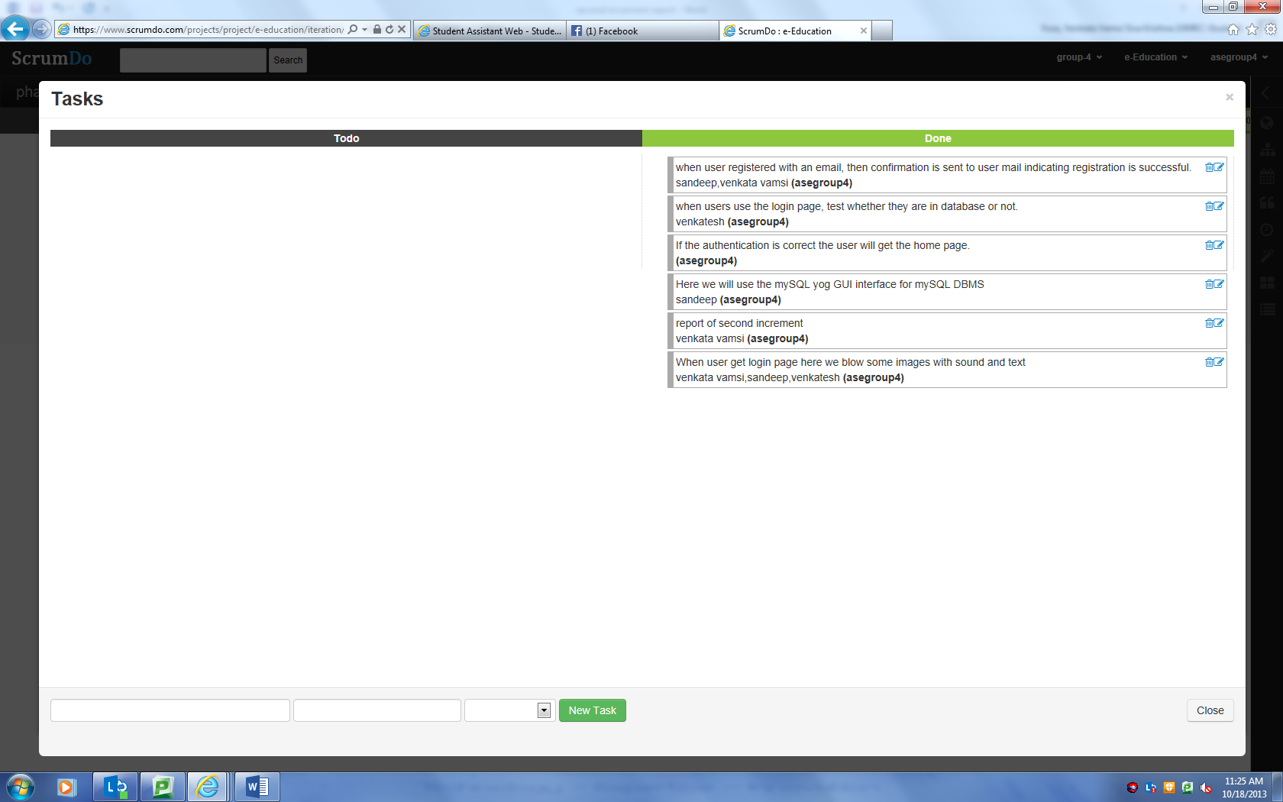

Showing the story-2 is completed:

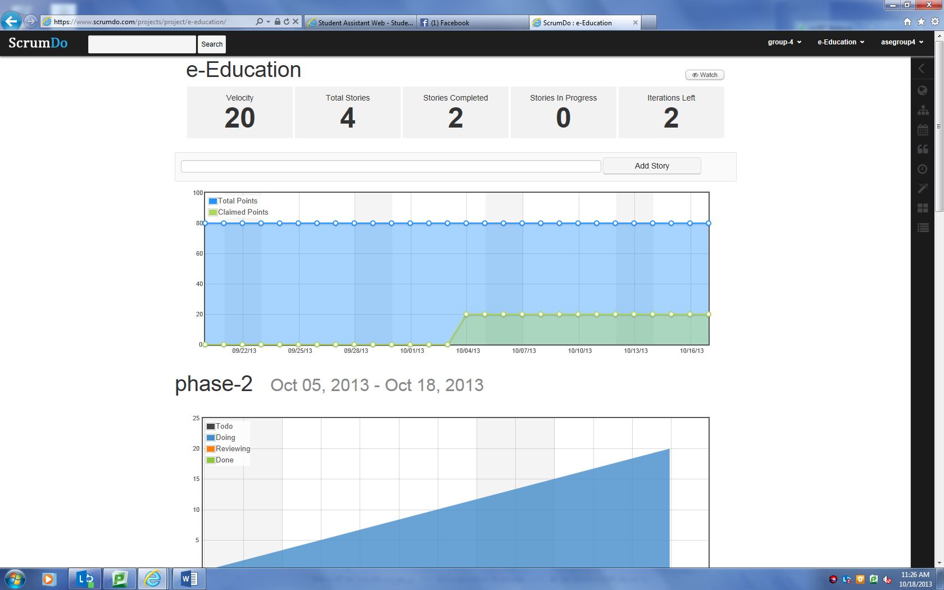

Phase-3 is in progress:

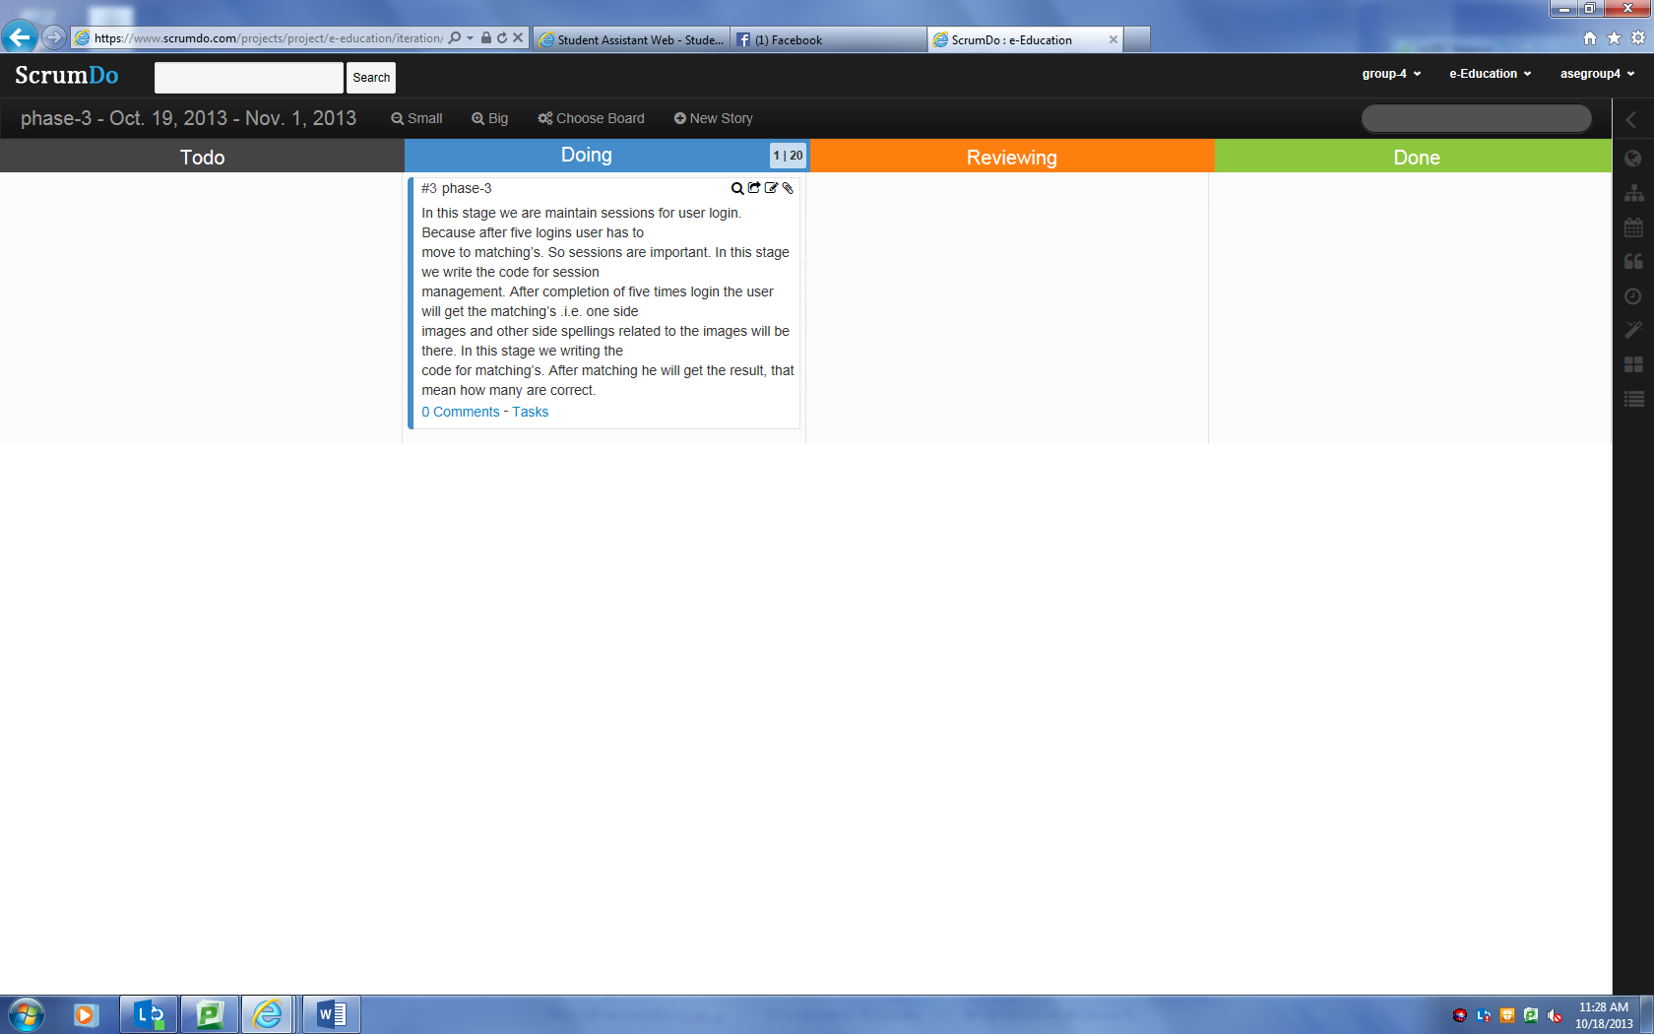

Scrum do link:

<https://www.scrumdo.com/projects/project/e-education/iteration/78653/board>

**LOGIN PAGE:**

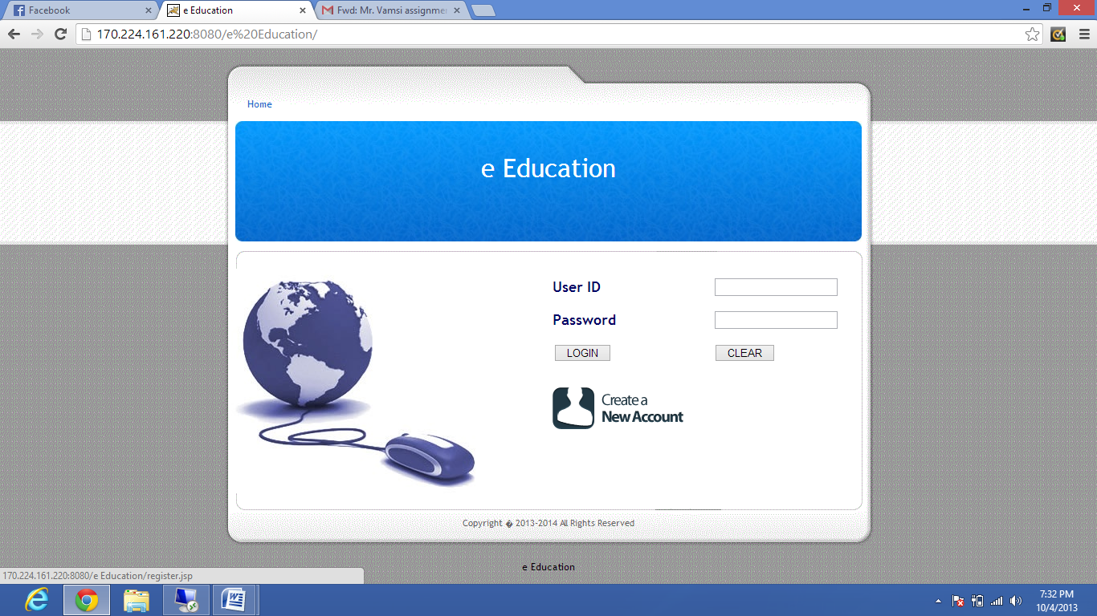

**creating the new account:**

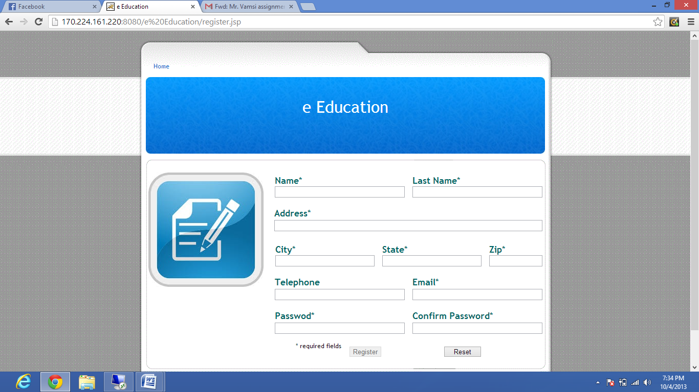

Register is success:

user ID is : user1101

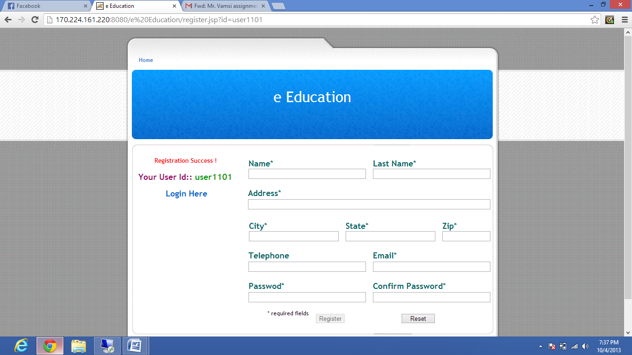

After registration login with user1101:

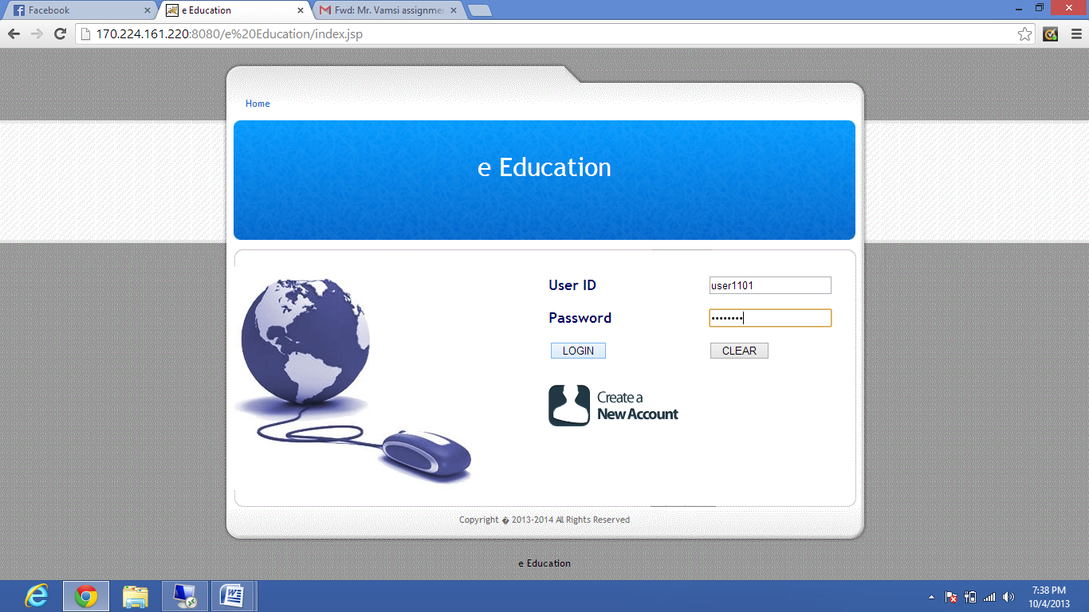

**Testing:**

Vaildation 1: Unknow username and password gives the message " your username and password is incorrect"(in next screen shot)

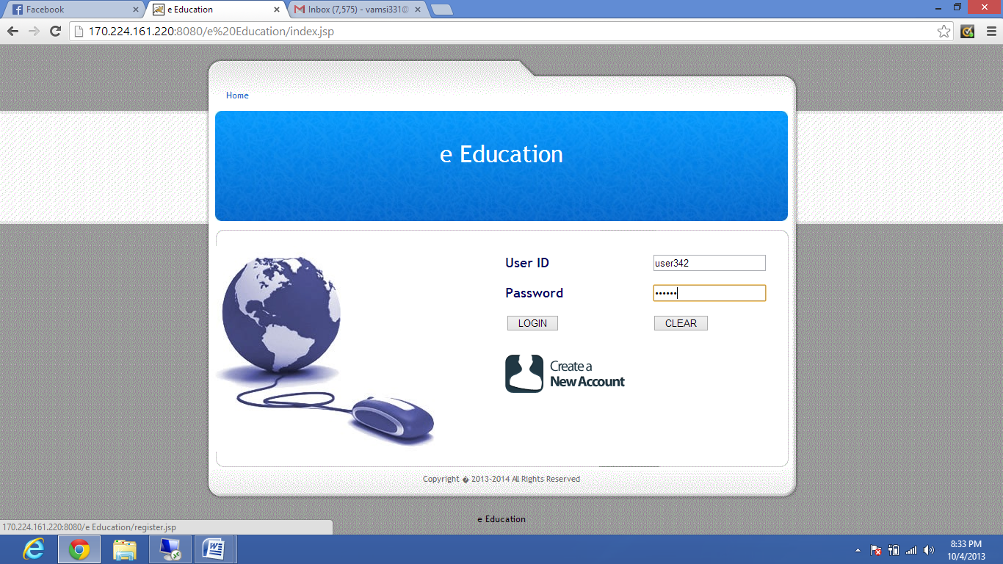

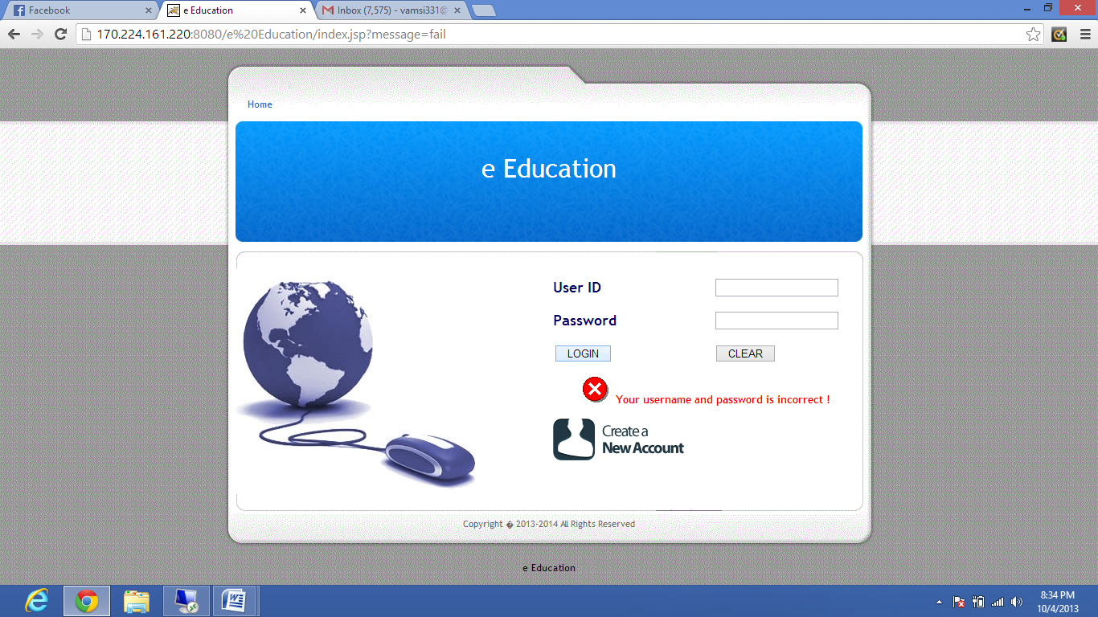

Validation 2:

Until all the essential fields are complete the register button will not enabled

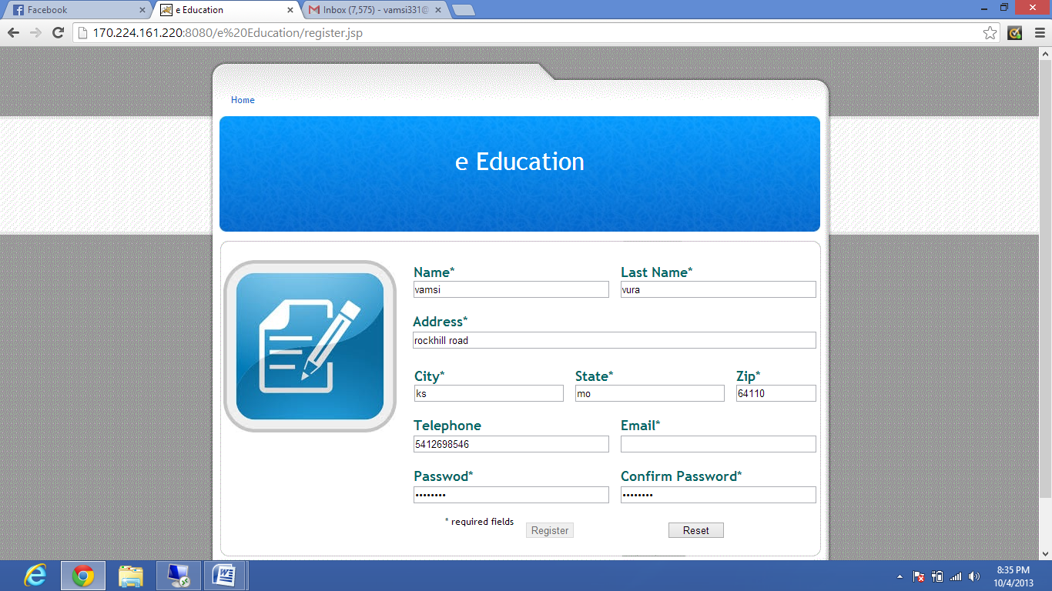

Validation 3:

User email ID should be in standard email format otherwise it shows "Invalid email address"

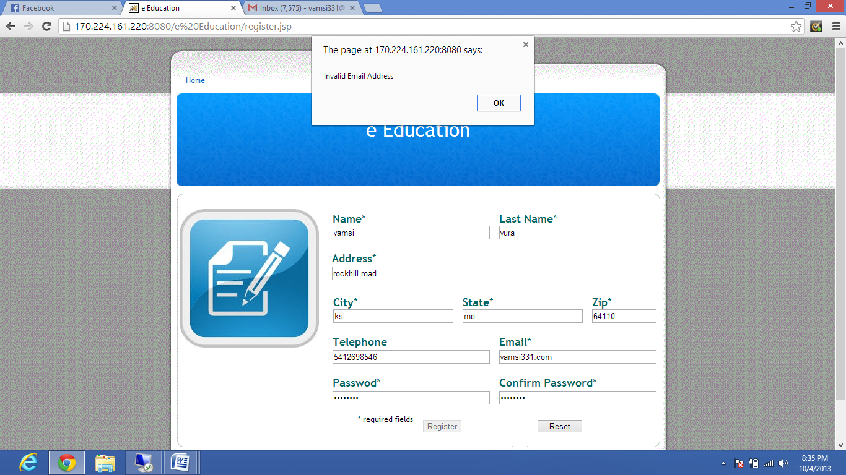

Validation 4:

If user enters the password and confirm password different it will show passwords do not match

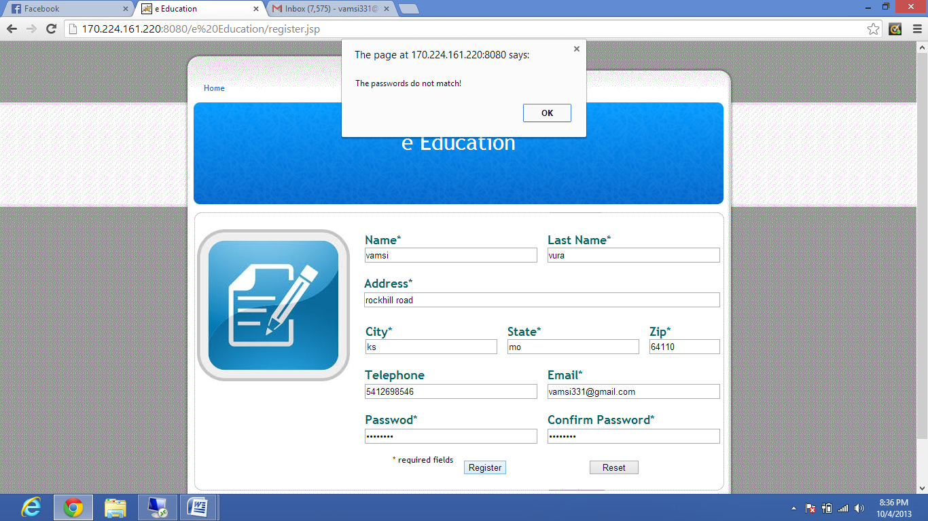

Collected images and voice recordings as shown below:

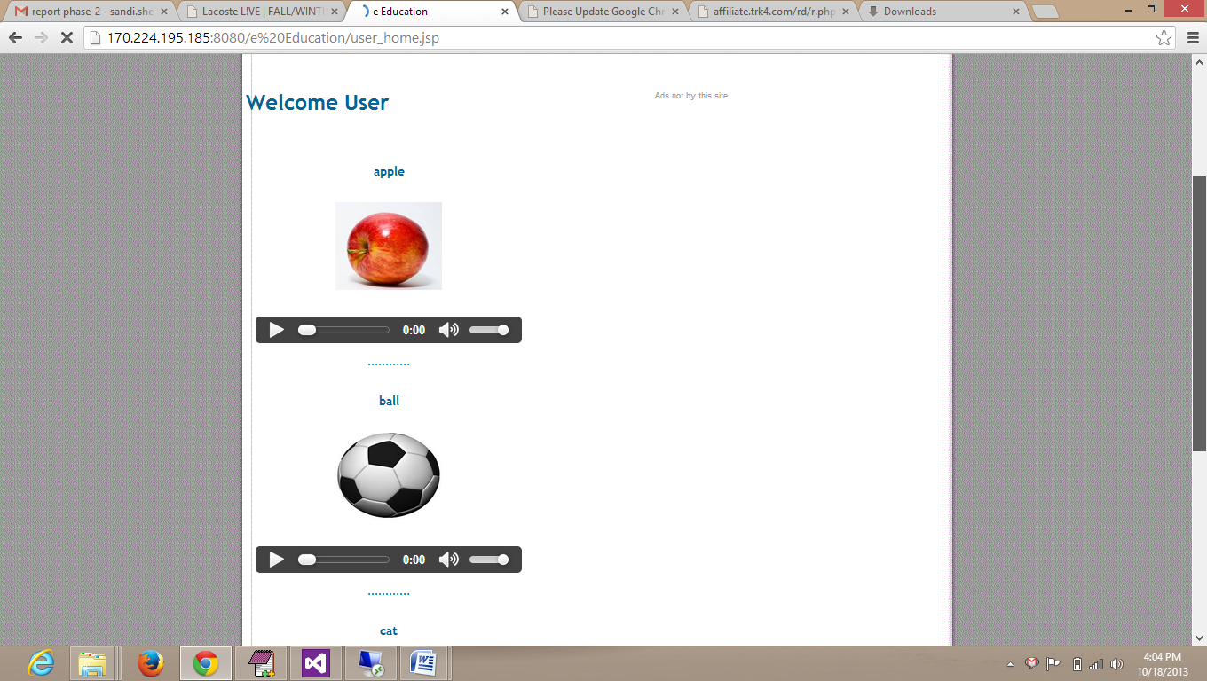

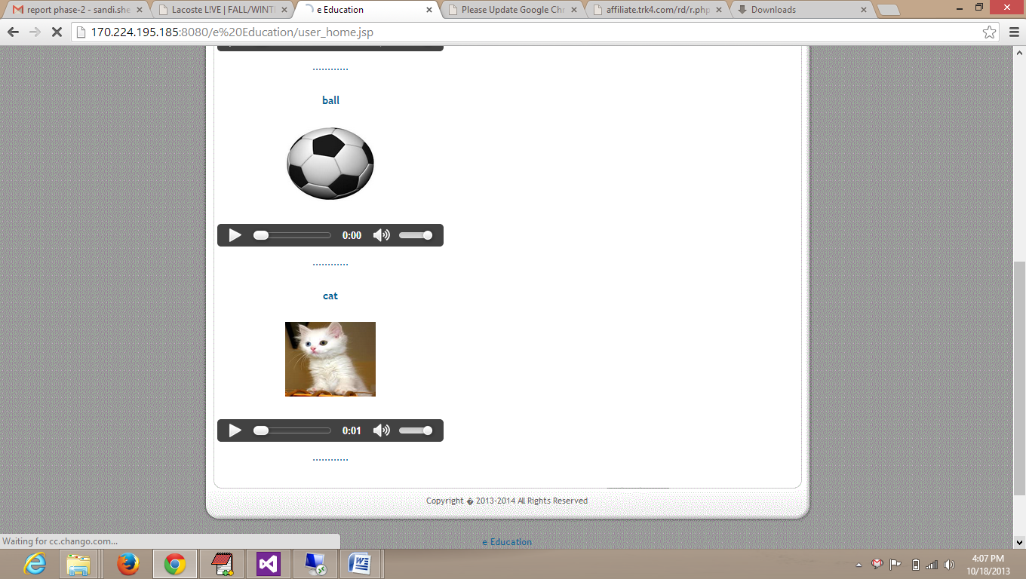

Then we collected some images and recordings based on the images and stored in mysql database. Then wrote a JDBC program to connect to the database.Then when an user visits website then user retrieves data from the database. In the same way, we are trying to place more images in our website.

Issues:

When a new user register on the page, an email confirmation should be sent to user automatically. We are trying to make a code for that. It is working on local machine but when trying to deploy in cloud we are getting an error. We try to rectify the error soon.

